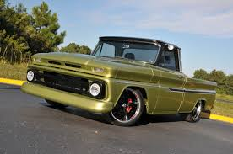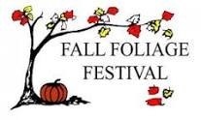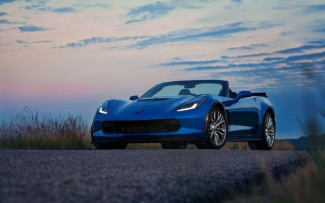

Fall Foliage Festival

Annual Car, Truck, and Motorcycle Show &

Oct. 12th 2019 -Swap Meet- 8am-1pm
Located at West Middle School
109 E. Garfield St., Martinsville, IN 46151
Show Participants Awards & Prizes
Registration: 8:00 a.m. – 11:00 a.m. (Oct.12th) Best of Show

Pre-registration fee: $10.00 (Deadline Sept.28th) People’s Choice and Top 20
Day of Show: $15.00 (Oct. 12) Many Specialty Awards

Judging - 11:00 a.m. to 12:00 p.m. Dash Plaques to First 100
Awards presented at 1:00 p.m.
Entries receive chance at door prizes
(Participants are asked to parade Indoor restroom facilities available
thru Downtown Square following awards)
Swap Meet Vendors
Parts, engines, hot rod/rat rod items, anything automotive related
Day of Show: $10.00 (Oct. 12)

Powered By:
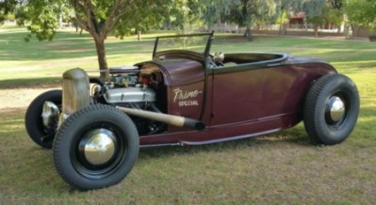

Name __________________________________ Make ________________________________
Address __________________________________ Model _________________________________
Phone ___________________________________ Year/color ______________________________
Make checks payable to Fall Foliage Festival and mail to: P.O. Box 1245, Martinsville, Indiana 46151
All pre-registrations must be mailed in prior to Oct. 1 deadline.
www.morgancountyfallfoliagefestival.com

