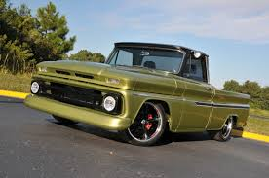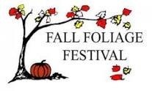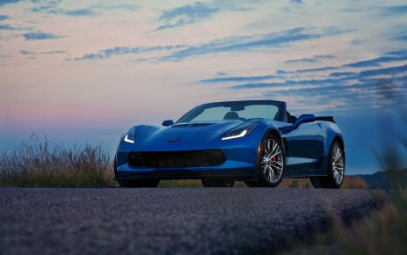

Morgan County Fall Foliage Festival

Annual Car, Truck, and Motorcycle Show

Oct. 12, 2019 -Swap Meet- 8am-1pm.

Located at John R. Wooden Middle School- 109 E. Garfield Ave. Martinsville, IN 46151
Show Participants Awards & Prizes
Registration: 8:00 a.m. – 10:00 a.m. (Oct. 12) Best of: *Show *GM *Mopar
*Ford *Rat-Rod *4x4
*Motorcycle
Pre-registration fee: $10.00 (Deadline Oct. 1) People’s Choice
Day of Show: $15.00 (Oct. 12) Specialty Awards
Judging - 11:00 a.m. to 12:00 p.m. Dash Plaques to First 100
Awards presented at 1:00 p.m. Door Prizes

(Participants are asked to parade
through downtown Martinsville following awards)

Swap Meet Vendors
Parts, engines, hot rod/rat rod items, anything automotive related
Day of Show: $10.00 (Oct. 12)

Name __________________________________ Make ________________________________
Address __________________________________ Model _________________________________
Phone ___________________________________ Year/color ______________________________
Make checks payable to Fall Foliage Festival and mail to: P.O. Box 1245, Martinsville, Indiana 46151
All pre-registrations must be mailed in prior to Oct. 1 deadline.

www.morgancountyfallfoliagefestival.com

