2021 Quilt Show
The Morgan County Schoolhouse Quilt Guild
Quilt Show will be held at the Morgan County
Fairgrounds.
Directions to Quilt Show
Morgan County Fairgrounds
4- H Building
1749 Hospital Dr.
Martinsville, IN 46151
The show dates are:
Thursday, October 7th - 12:00 until 8:30 PM
Friday, October 8th - 11:00 AM until 8:30 PM
Saturday, October 9th - 9:00 AM until 8:30 PM
2021 Quilt Show
Special Exhibits
"Panel Palooza"

A special quilt exhibit featuring our
2021 guild challenge use of panels, and
will also feature our Snowflake
Block of the Month.
- Educational quilting demonstrations:
Watch some of our masters at work!
• Spirit of 45 Highlights display of quilts
• Exhibit of the Guild Charity projects.
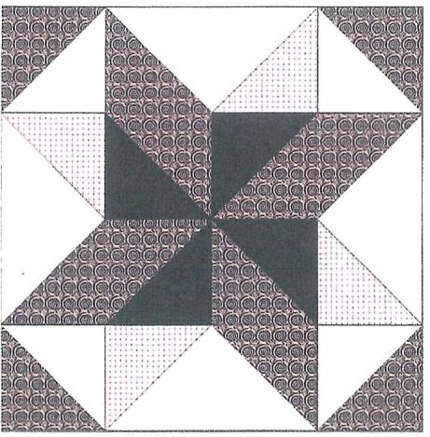
Morgan County Schoolhouse
Quillers' Guild
Quilt Guild meets at the Martinsville
First Church of the Nazarene, 1609 John
Wooden Dr, Martinsville, IN 46151 on
the third Tuesday of each month at 6:30
PM.

For questions regarding the 2021 quilt
show, please contact Barbara Moon or
Cathy Honeycutt.
Phone: 317-450-4044 or 317-730-3504
Email: MCSQuiltGuild@yahoo.com
Facebook: Morgan County Schoolhouse
GUILD MISSION STATEMENT
The MCSQG is dedicated to promote
fellowship and education among persons
interested in all aspects of quilt making;
preserve our quilt making heritage and
traditions; and promote and participate in quilt
related projects that are of service to others.
Morgan County
Schoolhouse
Quilt Guild
2021
quilt Show
October 7th through October 10th
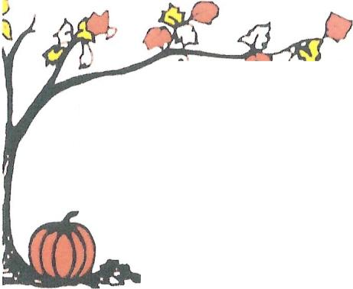
f!J '.:;J ~ ~
FALL FOLIAGE
FESTIVAL
0&
Morgan County
Fairgrounds

4- H Building
1749 Hospital Dr.
Martinsville, Indiana 46151

MORGAN COUNTY QUILT GUILD
Charities
- Stability First: Magdalene House, Lynay
Center:
- Quilts donated for each girl that
graduates her classes.
• IN Spirit of 45' /Bugles Across America:
- Dedicated to honoring all who
serve our nation in the city of
Martinsville.
- Red/white/blue quilts are
donated, then distributed to the
families of fallen soldiers.
• Desert Rose:
- Quilts provided for mothers and
children.
- Pillow cases provided to the
children to carry their personal
items.
• CASA: Courts:
- Pillow cases donated to the
children within the court system
to carry their belongings.
• Humane Society:
o Curtains and pads for cages.
• Habitat for Humanity:
- A quilted wall hanging is donated
for each build.
• Miscellaneous Donations:
- Nursing Homes
- Police and Fire Departments
- Care Net Pregnancy Center
- Quilts donated to organizations
for their fundraiser to raffle.

DON'T FORGET!
All quilts must have a four-inch sleeve
attached to the back of each quilt. All items
must be in protective covering, a pillowcase,
with name attached. No Sleeve, No Entry.
AWARDS
Ribbons will be awarded to First, Second and
Third Place winners in each category. Best of
Show will be chosen from all first-place
winners from each category, with a People's
Choice Award from all categories.
ENTRY FEE
A $5.00 fee for each item being entered in the
quilt show. Please make checks out to Morgan
County Schoolhouse Quilt Guild. (MCSQG)
DROP OFF TIMES
Quilts will be accepted on Tuesday, October
5th from 9:00 AM-12:00 PM, and from 5:00-
7:00 PM at the 4-H Building at the
fairgrounds.
PICKUP TIMES
Pickup of items will be on Sunday from 4:00
PM to 5 :00 PM.
JUDGING
All judged quilts will receive comments from
the judge in an envelope at time of pick-up.
NOTE
No quilts previously entered in the Fall Foliage
Festival Quilt Show will be permitted.

ENTRY CATEGORY
DEFINITIONS
- Hand quilted - Pieced and
applique, if piecing dominates.
- Machine quilted - Home machine
- Pieced and applique, if piecing
dominates.
- Machine quilted - Long arm -
Pieced and applique, if piecing
dominates
- Applique - If applique dominates
- 51% or more.
- Embroidery/Cross stitch -
If technique dominates = 51%
or more.
- Panels - Any panel project
regardless of use.
- Small quilts - any quilt with a
maximum of 60" on any side. (No
panels)
- Miscellaneous - Wall hangings,
art quilts, table runner, bags,
etc.
Final determination of category
will be made at time of check-in ..

