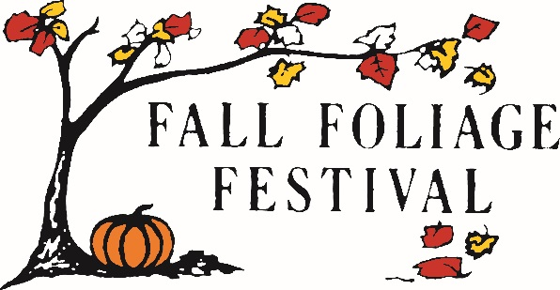

Greetings from the 2022 Morgan County Fall Foliage Festival Board!

The 63rd annual Morgan County Fall Foliage Festival will be held on October 6-9, 2022 in beautiful downtown Martinsville. We will be celebrating, in collaboration with, the City of Martinsville and Morgan County’s dual Bicentennial Years!
Throughout this four-day festival we will provide a variety of exciting events and contests. We have over 100 craft booths, nightly live music, a classic car show and a scholarship based Queen pageant. Sunday afternoon our massive parade marches through town for thousands of patrons of all ages to enjoy.
Our overall goal is the success of the festival. For this to occur the FFF board is in need of monetary sponsorships. We offer various levels of sponsorships ranging from the ‘Friends of the Festival’ sponsor up to the ‘Platinum’ sponsorship. Each level of sponsorship has specific advertising benefits, but can be customized to meet your needs. (see attached sponsorship sheet for the various levels and their benefits.) In some instances, contest participants are given In-Kind Gifts from various businesses or organizations for an award. In the past we have received race tickets, signed professional athlete/actor photographs, various service gift certificates or gift baskets, discount cards or other donated items. This In-Kind type of gift is very well received and has turned out to be a motivator for participation. This is a great opportunity for our supporting sponsors as this usually brings additional patronage to those businesses.
Our festival offers local businesses and corporate organizations an opportunity to offer family friendly entertainment. We would like to extend an offer to your company to align with our unique event by requesting a monetary sponsorship of any caliber or an In-Kind Gift donation to be used during the 2022 Morgan County Fall Foliage Festival.
*All monetary sponsorships and In-Kind donations will be announced as such during the specific awards ceremonies and participants will be listed on our website as contributing partners to the FFF*

If you have any questions or concerns, please feel free to email the festival office at office@morgancountyfallfoliagefestival.com.

Thank you for providing us with the opportunity to partner with your business!

Looking forward,

The 2022 Morgan County Fall Foliage Festival Sponsorship Committee

PO Box 1245
Martinsville IN 46151
Phone: 765.342.0332
(The Morgan County Fall Foliage Festival is a non-profit 501C3 organization. Tax ID# 35-1389781)

