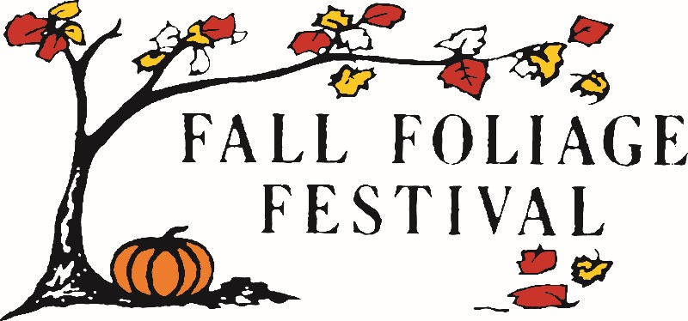
SPONSORSHIP LEVELS FOR THE 2022 MORGAN COUNTY
FALL FOLIAGE FESTIVAL

Plantinum Leaf | $5,000 or more
- Mentioned in radio, newspaper, and social media advertising
- Large ad on the FFF website with a link to sponsor's website
- Facebook Mention
- Street Banner - FFF bright orange pole banners hung throughout town

Gold Leaf | $3,000 to $4999
- Mentioned in radio, newspaper, and social media advertising
- Medium ad on the FFF website with a link to sponsor's website
- Facebook Mention
- Street Banner - FFF bright orange pole banners hung throughout town

Silver Leaf | $1,000 to $2,999
- Mentioned in radio, newspaper, and social media advertising
- Small ad on the FFF website with a link to sponsor's website
- Facebook Mention
- Street Banner - FFF bright orange pole banners hung throughout town

Bronze Leaf | $500 to $999
- Mentioned in radio, newspaper, and social media advertising
- Listed on the FFF website list of sponsors
- Facebook Mention
- Banner displayed at sponsored event

Maple Leaf | $100 to $499
- Mentioned in radio, newspaper, and social media advertising
- Listed on the FFF website list of sponsors
- Facebook Mention

Friends of the Festival | $99 or less
- Mentioned in radio, newspaper, and social media advertising
- Listed on the FFF website list of sponsors

In Kind Gift Gift Certificate (any value)
-Listed on the FFF website list of sponsors

