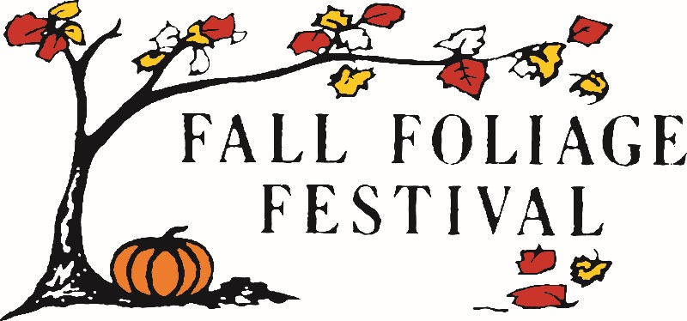
SPONSORSHIP LEVELS FOR THE 2023 MORGAN COUNTY
FALL FOLIAGE FESTIVAL

Platinum Leaf | $5,000 or more
- Mentioned on radio, in newspaper and on social medias
- Sponsors name and logo on the FFF website with a link to sponsor's website
- Street banner (orange banner with logo hung downtown)
- Logo on board member shirts
- Free outdoor booth during festival ($100 value)
- Maple Leaf Plaque
Gold Leaf | $3,000 to $4999
-Mentioned on radio, in newspaper and on social media
-Sponsors name and logo on the FFF website with link to sponsor’s website
-Street banner (orange banner with logo hung downtown)
-Logo on board member shirts
-Maple Leaf Plaque
Silver Leaf | $1,000 to $2,999
- Mentioned on radio, in newspaper and on social media
- Sponsors name and logo on the FFF website with link to sponsor’s website
- Yard sign with sponsors logo
- Maple Leaf Plaque

Bronze Leaf | $500 to $999
- Mentioned on radio, in newspaper and on social media
- Sponsors name listed on the FFF website list of sponsors
- Yard sign with sponsors logo
Maple Leaf | $100 to $499
- Mentioned on social media
- Listed on the FFF website list of sponsors
Friends of the Festival | $99 or less
- Mentioned on social media
- Listed on the FFF website list of sponsor

In Kind Gift or Parade Specific Sponsors (See categories on separate paper)

