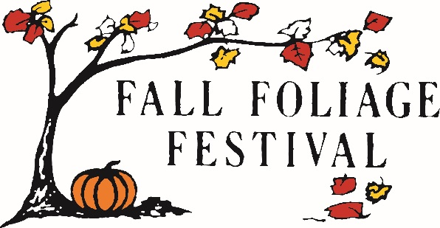

Greetings from the 2023 Morgan County Fall Foliage Festival Board!

We are thrilled to announce the 64th annual Morgan County Fall Foliage Festival is returning to downtown Martinsville on Thursday, October 12 through Sunday, October 15th 2023!

Throughout this four-day festival, we provide a variety of exciting events including a carnival for all ages, 100+ booths of various arts, free live music, a classic car show, a scholarship based queen pageant, food trucks, a 5K foot race and a massive parade that marches through the city streets on Sunday afternoon!
Our hope is to bring families to beautiful Morgan County to explore and visit the historic town square to enjoy a clean and safe, family-fun weekend of fall festivities.

For this beloved town tradition to continue, the festival board is requesting monetary donations from our friends and neighboring businesses. We offer various levels of monetary sponsorships ranging from: Friends of the Festival ($1-$99) up to Platinum ($5,000+) as well as individual event and parade division or award sponsors. Each level of sponsorship has specific advertising benefits that can be customized to meet your donation amount. (see attached sponsorship sheet for the various levels and their benefits.)
We also understand that monetary donations can be tough to come by so we have added the option of an In-Kind Gift donor. In the past, we have received In-Kind Gifts such as; event tickets or venue membership cards, autographed professional athlete/actor memorabilia, various service gift certificates or product gift baskets, in-house discount cards and other donor specific items. The FFF board members are graciously requesting a monetary sponsorship or In-Kind Gift donation of any caliber in support of the continued success of the Morgan County Fall Foliage Festival.

We are so very thankful to our friends and local businesses or organizations that have provided partnership with us in support of our annual town festival. We appreciate your kindness over the years and are grateful for your donations!

Thank you for providing us with the opportunity to partner with you!

Looking forward,

The 2023 Morgan County Fall Foliage Festival Sponsorship Committee
office@morgancountyfallfoliagefestival.com
128 N Jefferson St.
Martinsville IN 46151
Phone: 765.342.0332
(The Morgan County Fall Foliage Festival is a non-profit 501C3 organization. Tax ID# 35-1389781)

